Execution screenshots
Azure Resource Environment
Shows the Azure resources: VM, Virtual Network, NSG, Public IP, NIC, and resource group
.
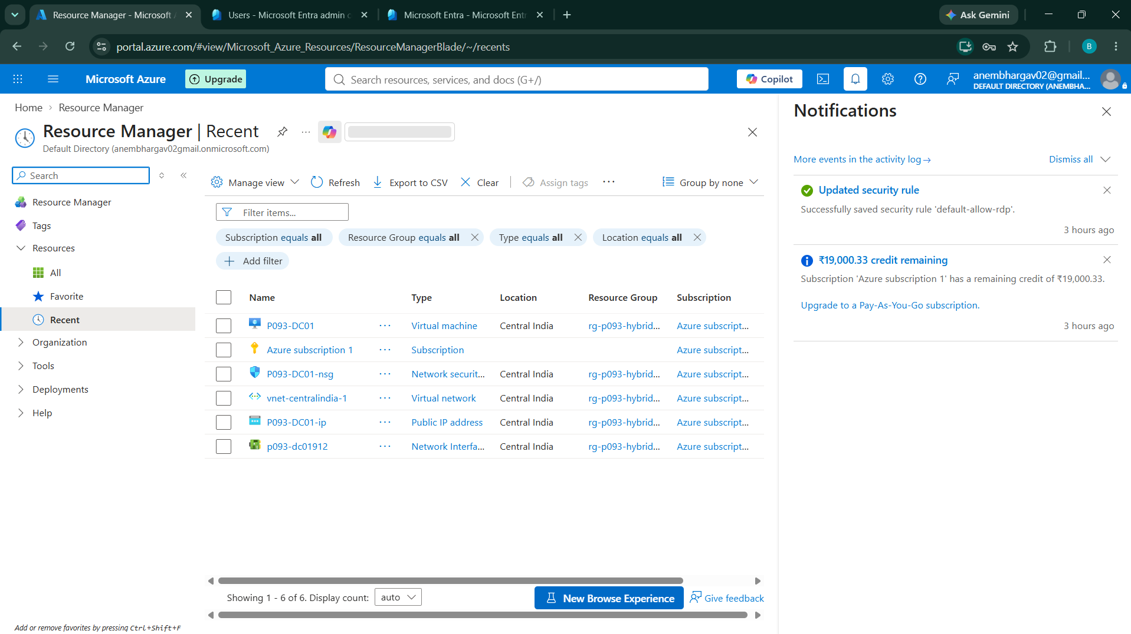
Windows Server / Server Manager
Shows the Windows Server with AD DS, DNS, and File and Storage Services configured.
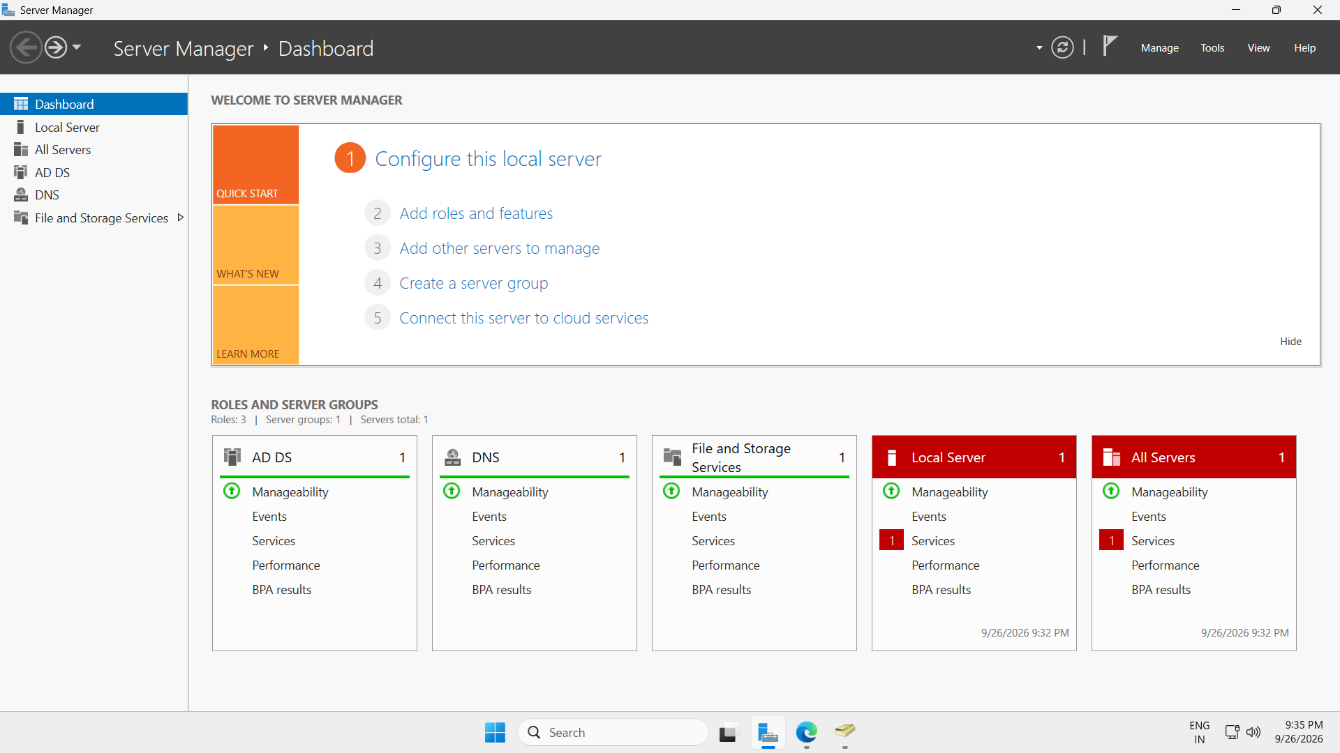
Active Directory Domain
Shows Active Directory Domains and Trusts with p093hybrid.local

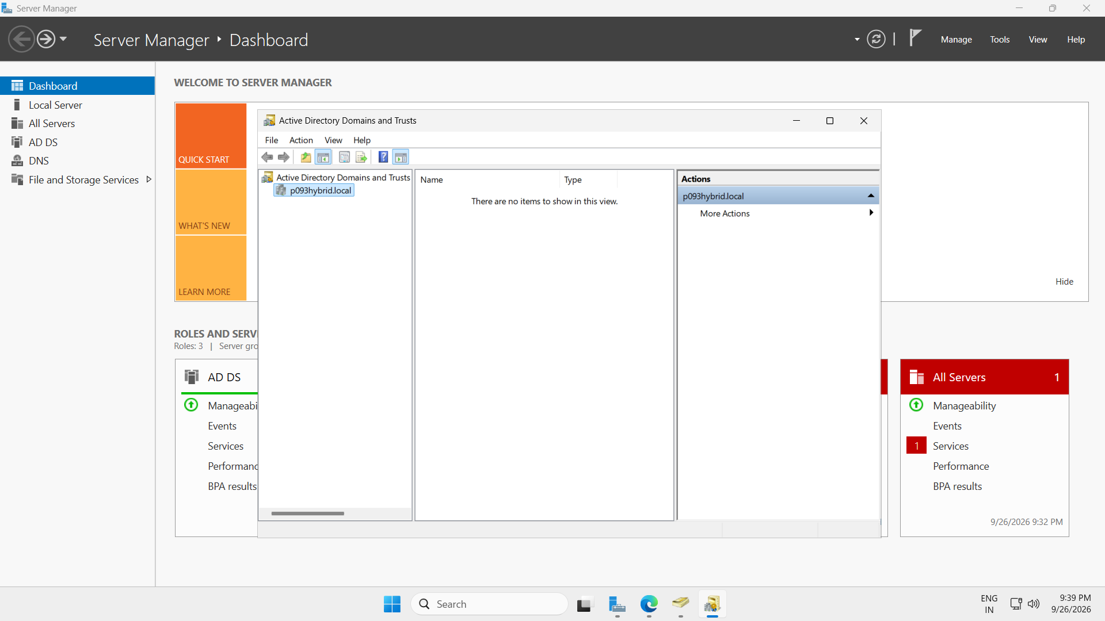
Active Directory Users
Shows P093-Users containing Test User1, Test User2, and Test User3
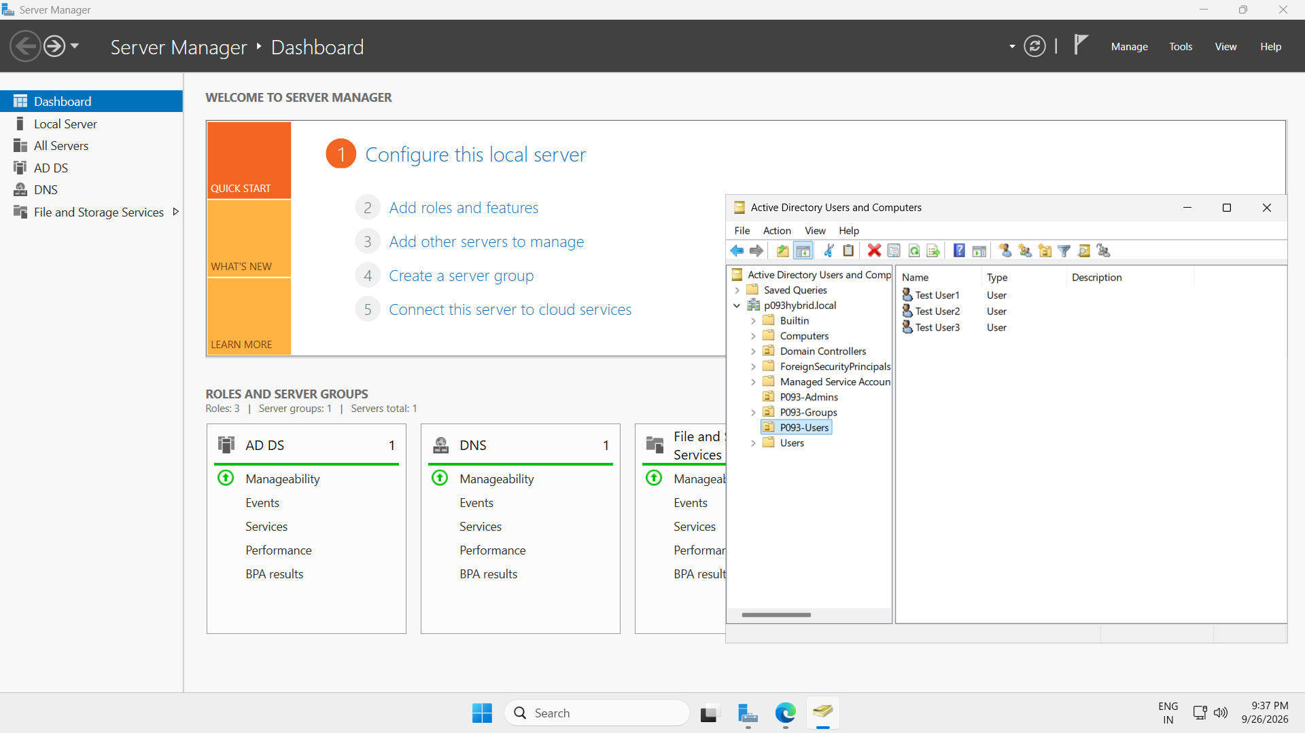
Active Directory Synchronization Group — Shows the P093-Sync-Users security group used for synchronization control.
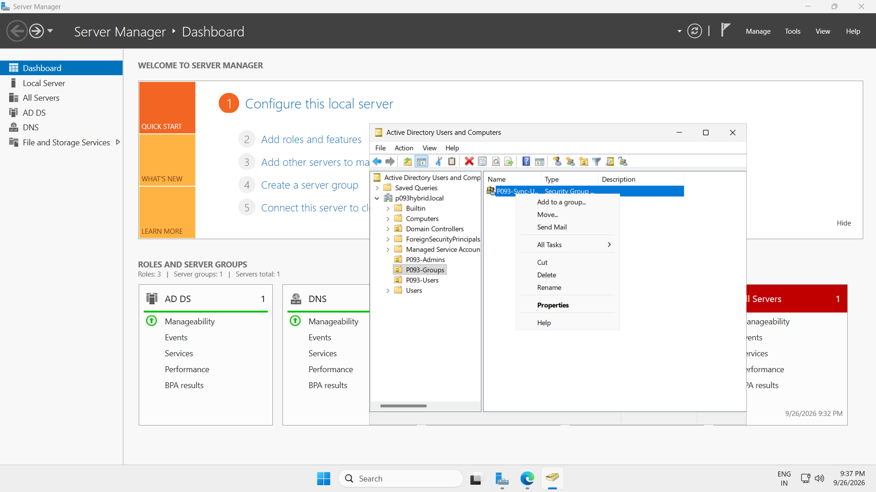
Microsoft Entra Admin Center
Shows the Entra tenant with Microsoft Entra Connect: Enabled and tenant information
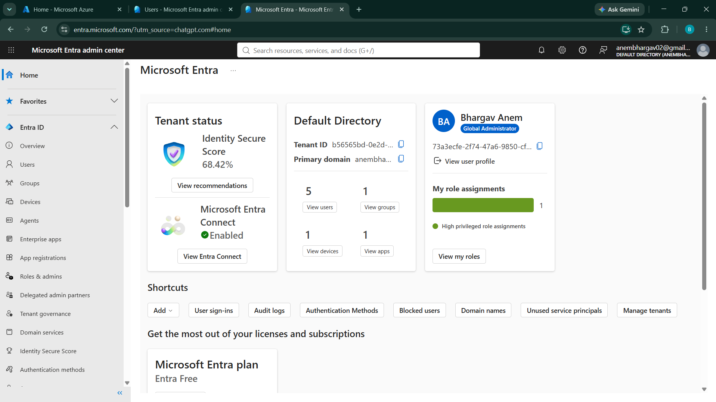
Synchronized Users in Microsoft Entra ID
Shows Test User1, Test User2, Test User3 with On-premises sync = Yes.
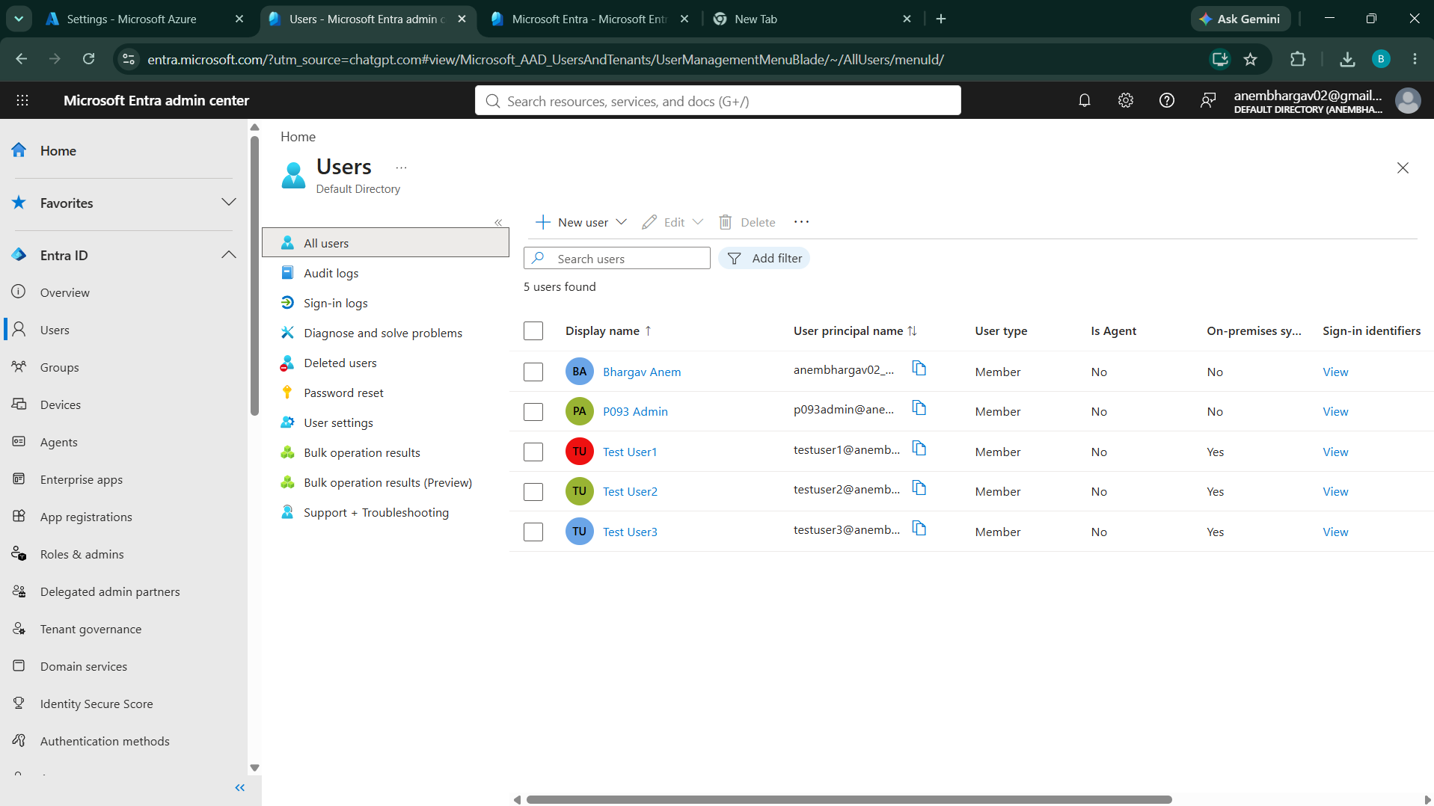
Cloud Authentication Verification : Successful cloud authentication using a synchronized hybrid identity 